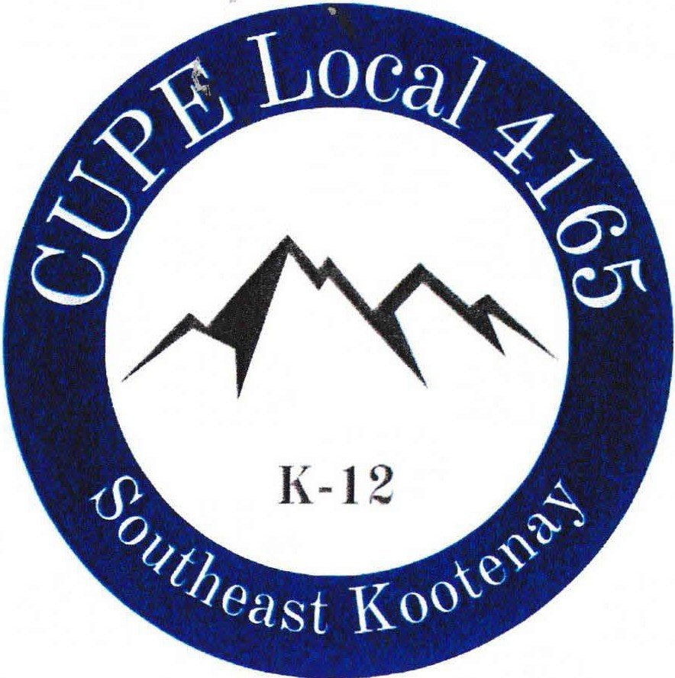



October 5, 2026
,:
I/
"/
,..,...
--
November 9,2026,
January 11, 2027
February 8, 2027
March 8, 2027
April 12, 2027
May 10, 2027
June 7,2027

AGM­
All regular meetings start at 7pm in person at the CUPE office in Cranbrook and via zoom. Zoom link sent out personal email addresses only!
September
12, 2026 2pm
Jaffray School •
' \ I I

